Temperature Control for Research and Industry

Model KLS-150
Manual

for KEM-Lab and KEM-Prep Reactors

Index

Safety Notices . . . . . . . . . . . . . . . . . . . . . . . . . . . . . . . . . . . . . . . . . . . . . . . 3
Controller Description . . . . . . . . . . . . . . . . . . . . . . . . . . . . . . . . . . . . . . . . 4
Description of Timer Components on KLS150/Timer . . . . . . . 5
Entering a Setpoint into the Controller . . . . . . . . . . . . . . . . . . . . . . . . . . 5
Timer Controls . . . . . . . . . . . . . . . . . . . . . . . . . . . . . . . . . . . . . . . . . . . . . . 6
Using the Temperature Ramp Feature . . . . . . . . . . . . . . . . . . . . . . . . . . . 7
KEM-Lab Reactor . . . . . . . . . . . . . . . . . . . . . . . . . . . . . . . . . . . . . . . . . . . . 8
KEM-Prep Reactor . . . . . . . . . . . . . . . . . . . . . . . . . . . . . . . . . . . . . . . . . . . 9

You’ve purchased the most versatile controller available to the research community. We’re confident it can regulate ANY heating/cooling situation you’ll ever encounter. If the information in this manual isn’t adequate to make your application work, call our Engineering Department for assistance.

Warranty
J-KEM Scientific, Inc. warrants this unit to be free of defects in materials and workmanship and to give satisfactory service for a period of 12 months from date of purchase. If the unit should malfunction, it must be returned to the factory for evaluation. If the unit is found to be defective upon examination by J-KEM, it will be repaired or replaced at no charge. However, this WARRANTY is VOID if the unit shows evidence of having been tampered with or shows evidence of being damaged as a result of excessive current, heat, moisture, vibration, corrosive materials, or misuse. This WARRANTY is VOID if devices other than the reaction block supplied with this unit are powered by the controller. Components which wear or are damaged by misuse are not warranted. This includes contact points, fuses and solid state relays.
THERE ARE NO WARRANTIES EXCEPT AS STATED HEREIN. THERE ARE NO OTHER WARRANTIES, EXPRESSED OR IMPLIED, INCLUDING BUT NOT LIMITED TO THE IMPLIED WARRANTIES OF MERCHANTABILITY AND OF FITNESS FOR A PARTICULAR PURPOSE. IN NO EVENT SHALL J-KEM SCIENTIFIC, INC. BE LIABLE FOR CONSEQUENTIAL, INCIDENTAL OR SPECIAL DAMAGES. THE BUYER'S SOLE REMEDY FOR ANY BREACH OF THIS AGREEMENT BY J-KEM SCIENTIFIC, INC. OR ANY BREACH OF ANY WARRANTY BY J-KEM SCIENTIFIC, INC. SHALL NOT EXCEED THE PURCHASE PRICE PAID BY THE PURCHASER TO J-KEM SCIENTIFIC, INC. FOR THE UNIT OR UNITS OF EQUIPMENT DIRECTLY AFFECTED BY SUCH BREACH.

J-KEM Scientific, Inc.  858 Hodiamont Ave.  St. Louis, MO 63112  USA | Phone: (314) 863-5536  FAX: (314) 863-6070  Web site: http://www.jkem.com  E-Mail: jkem911@jkem.com

Safety Notices

Solvents and Vapors

J-KEM’s KEM-Lab Reactor should not be used in an environment containing flammable organic or gas vapors. It is recommended that the KEM-Lab Controller be placed outside of the research hood and the reactor be placed inside of the hood.
CAUTION: This equipment should only be operated by qualified personnel knowledgeable in laboratory procedures.

Symbols

Power Switch: 1 - Mains power (120vac for USA and Canada) (230vac for Europe) is ON
0 - Mains power (120vac for USA and Canada) (230vac for Europe) is OFF

 | Caution. Risk  of electric  shock. |  | Caution. No  user serviceable  parts. |  | Protective conductor terminal. Earth Ground.

General Notice

WARNING: If equipment is not used as specified in this manual, the protection provided by this equipment may be impaired.

CAUTION: When operating this equipment insure that the reaction block is located away from flammable object.

Stability

The KEM-Lab controller is equipped with a side mounting clamp. The controller should not be clamped to a free standing ring stand that can tip over. The KEM-Lab controller should only be clamped to lattice networks securely attached to a bench or laboratory hood.

Power

Voltage: 120-240 VAC @ 50-60Hz
Wattage: 600 watts
Fusing (USA): 5 amp fast acting (F) 120 vac fuses
Fusing (Europe): 3 amp fast acting (F) 240 vac fuses

Environmental

Indoor use
Altitude up to 2000 meters
Operating temperatures of 5o C to 40o C
Maximum relative humidity of 80% for temperature up to 31o C decreasing linearly to 50% relative humidity at 40o C.
Installation category II
WARNING: The KLS controller is exclusively made for use with J-KEM Scientific’s KEM-Lab and KEM-Prep reactors. Use of any other heater with the controller will void warranty and create a significant safety hazard.

Controller Description

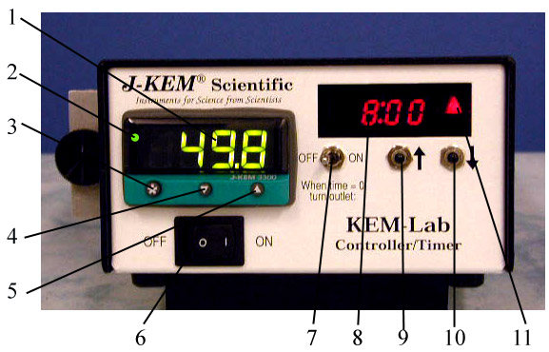  Model KLS150/Timer Front | 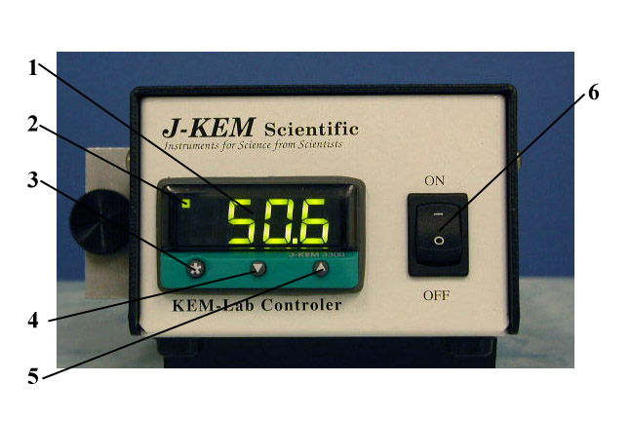  Model KLS150 Front
Both the KLS150 and KLS150/Timer temperature controllers are CE approved. | 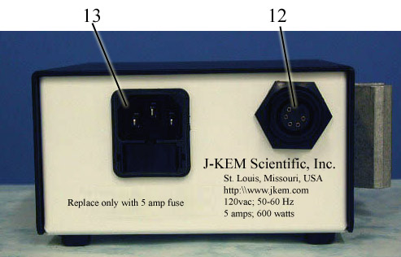

1. Temperature Display. Shows temperature of the process as the default display. Shows set point temperature (i.e. desired temperature) as a blinking number when ‘*’ button is held in.

2. Indicates that heating power is being applied to the heater when lit.

3. Control Key. When held in, the display shows the set point temperature. To decrease or increase the set point, press the ‘t’ key (4) or ‘s’ key (5), while simultaneously holding in the control key. The set point appears as a blinking number in the display.

4. Lowers set point when ‘*’ button (3) is simultaneously pressed.

5. Raises set point when ‘*’ button (3) is simultaneously pressed.

6. Controller On/Off switch.

Description of Timer Components on KLS150/Timer Controller

7. Timer Switch. This switch, in conjunction with the timer, determines if power is applied to the heater. See Section *. The label ‘When time = 0 turn outlet:’ has reference to the time remaining in the display (8).

8. Displays the time remaining in the timer in the format of ‘Hr:Min’.

9. Increases the time remaining in the timer when pressed.

10. Decreases the time remaining in the timer when pressed.

11. Indicates whether the timer section will allow power to be ON or OFF to the heating block. This LED is lit when the timer section will allow the controller to heat the reaction block and off when the reaction block will not be heated (see section titled ‘Timer Controls’).

12. KEM-Lab Reactor connector. Only J-KEM’s KEM-Lab reactor should be connected to this receptacle. Connecting any other device will cause a significant safety hazard and voids the warranty.

13. Mains Power Connection. The fuses internal to this connection must only be replaced with fast acting (F) fuses of the following amperage:
120 VAC input (USA and Canada): 5 amps.
220-240 VAC input (Europe): 3 amps.

Entering a Setpoint into the Controller

1. Turn power on to the digital temperature controller. The default display (when no buttons are being pressed) of the controller is the current reactor temperature.

2. To see the current setpoint temperature
(i.e., the desired temperature), press and hold in the ‘*’ button on the front of the digital meter. The current setpoint appears as a blinking number in the display. To enter a new setpoint, hold in the ‘*’ button on the front of the meter. While holding in the ‘*’ button press either the s button to increase, or the t button to decrease the setpoint. When the desired temperature is present in the display, release all the buttons.

Timer Controls

NOTE: This section applies only to KLS150/Timer temperature controllers with 100 hour digital timer

The timer section turns heating to the reactor either ON or OFF in an unattended operation when the time in the timer counts to zero. To adjust the time in the timer press the [UP arrow] or [DOWN arrow] buttons (9 & 10) to increase or decrease the displayed time. The format of the display is ‘Hr : Min’. A simple way to know whether heat is being applied to the reactor is by the state of LED 11 which is lit when the heat is on and not lit when it’s off.
The position of switch 7 determines whether heat to the reactor is ON or OFF depending on whether any time present in the timer. To understand the effect of switch 7, take the example where switch 7 is set to the OFF position (i.e., “When time = 0 (zero), turn outlet: OFF”). If there is time present in timer 8 then heat to the reactor would be ON, since time ≠ 0. When the timer counts down to zero heat to the reactor is turned OFF because this fills the requirements of the position of switch 7 (i.e., ‘When time = 0, turn outlet: OFF). When not using the timer, the normal position of switch 7 is the ON position with no time in the timer window 8. If switch 7 is set to “When time = 0, turn outlets: ON”, heat to the reactor is on since the time does equal zero. The effect of the position of switch 7 on heating the reactor is summarized below.

Switch 7 | Time Remaining | Reactor | LED 11
Position | in Timer | Heating: | is | Comment
[When time = 0  turn outlet:] | Zero | OFF | OFF
OFF | >Zero | ON | ON | Heat to the reactor remains ON until the timer counts down to zero, at which point heat is turned OFF and stays off indefinitely.
[When time = 0  turn outlet:] | Zero | ON | ON
ON | > Zero | OFF | OFF | Heat to the reactor remains OFF until the timer counts down to zero, at which point heating turns ON and stays on indefinitely.

WARNING: A potential danger exists when using the timer to turn the reactor ON when the timer counts to zero. In the event of a power failure, any time present in the timer is lost. When power comes back on, the timer resets to zero which results in heat to the reactor being turned ON. Therefore, only processes that pose no danger when heated indefinitely should be set up to turn on when the timer counts to zero.

Using the Temperature Ramp Feature.

The controller can be programmed to heat or cool at a user specified rate. A single temperature ramp step and hold step are standard in all J-KEM controllers. Optionally, the controller can have up to 126 temperature ramps steps.

A temperature ramp consists of a ramp step (heating or cooling) and a soak step. The rate of temperature ramping and the duration of the soak step are set by the user.
To start a temperature ramp follow these steps.

1. Set up the reaction, turn on the controller, and enter the desired ramp rate into the meter by:
Place the controller in programming mode by holding in both the t and s keys on the front of the temperature meter until the word “tunE” appears in the display, then release both keys.
Press the s key 8 times until the word “SPrr” appears in the display. Next, hold in the ‘*’ key, then while holding in the ‘*’ key press the s or t key until the desired ramp rate appears in the display. Let go of all the keys. Ramp rates are entered in units of degrees/hour and has a range of 0 to 9900 degrees/hour.

2. Enter the soak time for the reaction. The soak time is the amount of time the reaction remains at the final setpoint temperature before turning heating off. Soak time can be set to a value of “- -“, or 0-1440 minutes. When soak time is set to “- -“ (two dashes in the display. This setting is one setting below ‘0’), the reaction ramps to the setpoint and then remains at the setpoint indefinitely. When set to a duration of ‘0’ minutes, the reaction heats to the setpoint and then turns off. When set to any value between 1-1440 minutes, the reaction heats to the setpoint and then stays at the setpoint for the number of minutes entered before turning off.
Press the s key 2 times until the word “SoAk” appears in the display. Next, hold in the ‘*’ key, then while holding in the ‘*’ key press the s or t key until the desired soak time appears. Let go of all the keys.
Exit programming mode by holding in both the t and s keys on the front of the temperature meter until the temperature appears in the display.

3. Enter the desired setpoint into to the controller. Start temperature ramping by:
Place the controller in programming mode by holding in both the t and s keys on the front of the temperature meter until the word “tunE” appears in the display, then release both keys.
Press the s key 9 times until the word “SPrn” appears in the display. Next, hold in the ‘*’ key, then while holding in the ‘*’ key press the s or t key until the word “On” appears in the display. Let go of all the keys.

Setting the value of “SPrn” to “Off” turns off ramping.
Exit programming mode by holding in both the t and s keys on the front of the temperature meter until the temperature appears in the display.

KEM-Lab Reactor

Connecting the KLS Controller to the KEM-Lab Reactor involves nothing more than connecting the gray power cord between the silver plug on the reactor and the black receptacle on the back of the KLS controller. Both the power and temperature sensor connections are made when the gray cord is attached. An accessory cord is available that separates the power and temperature sensor connections which allows the use of an external temperature sensor. An external sensor can be placed at any appropriate point on the reactor, but is usually placed in one of the reaction vials to sense solution temperature.
The temperature limit when using the internal electric heater is 130º C. Cooling fluids can be anything from liquid nitrogen to tap water. All styles of KEM-Lab reactors are CE approved.

Three styles of KEM-Lab reactors are available:
Heated: This style will be a single layer block and have only the silver electrical connector.

Heated & Cooled: This style is a single layer block with the silver electrical connector and stainless steel coolant ports for circulating coolant.

Reflux: This is a three layer block (pictured below). The bottom heated layer has the silver electrical connector, the top layer has stainless steel coolant ports (for circulating coolant to condense solvent vapor at the upper portion of the tube), and a gold insulating middle layer.

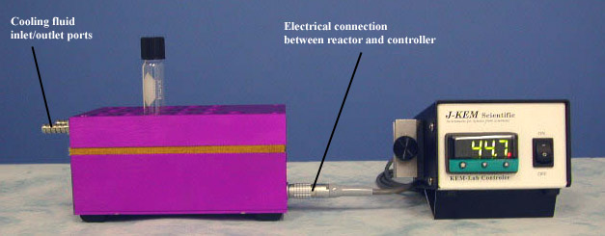
KEM-Prep Reactor &
Personal Reaction Station

Connecting the KLS Controller to the KEM-Prep Reactor or the Personal Reaction Station involves nothing more than connecting the gray power cord between the silver plug on the reactor and the black receptacle on the back of the KLS controller. Both the power and temperature sensor connections are made when the gray cord is attached. An accessory cord is available that separates the power and temperature sensor connections which allows the use of an external temperature sensor. An external sensor can be placed at any appropriate point on the reactor, but is usually placed in one of the reaction tubes to sense solution temperature.
The temperature limit when using the internal electric heater is 130º C. Cooling fluids can be anything from liquid nitrogen to tap water. All styles of KEM-Prep reactors and the Personal Reaction Station are CE approved.

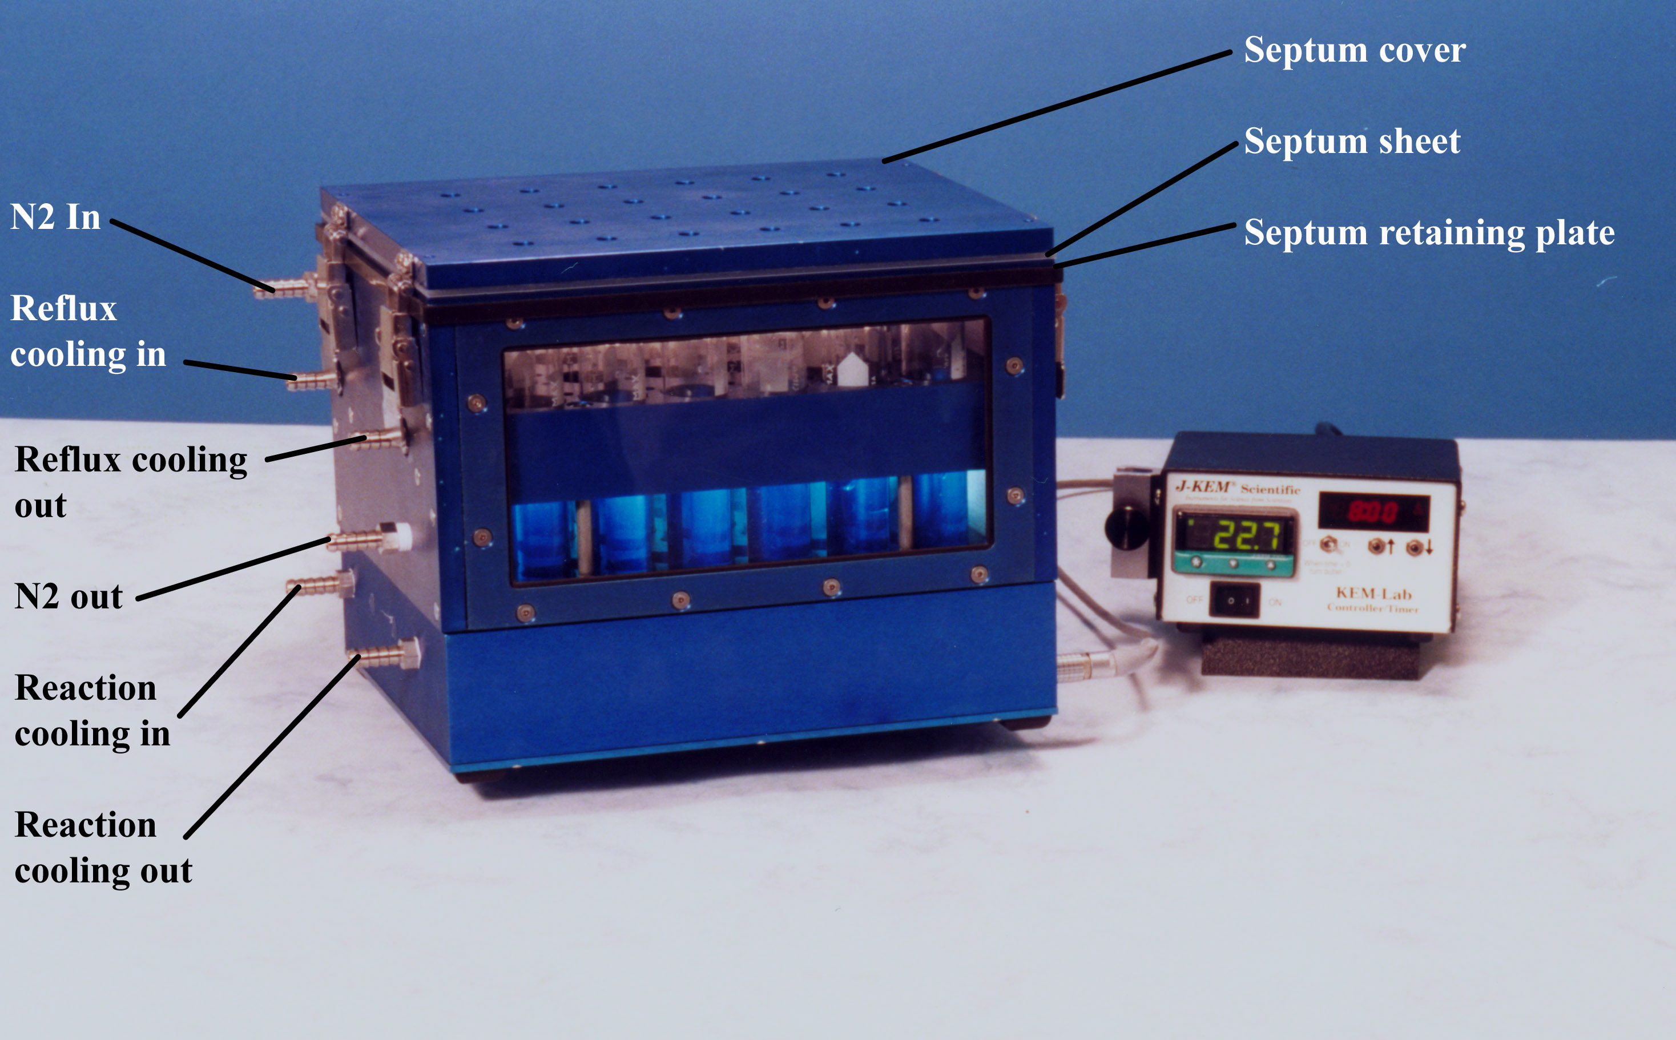

The Personal Reaction Station (pictured at right) is a 6-position version of the 24-position KEM-Prep Reactor. Except for the number of reaction positions, the two reactors are identical in features and operation. All 6 reaction positions of the Personal Reaction Station can be simultaneously stirred by setting it on top of a standard laboratory magnetic stirrer. | 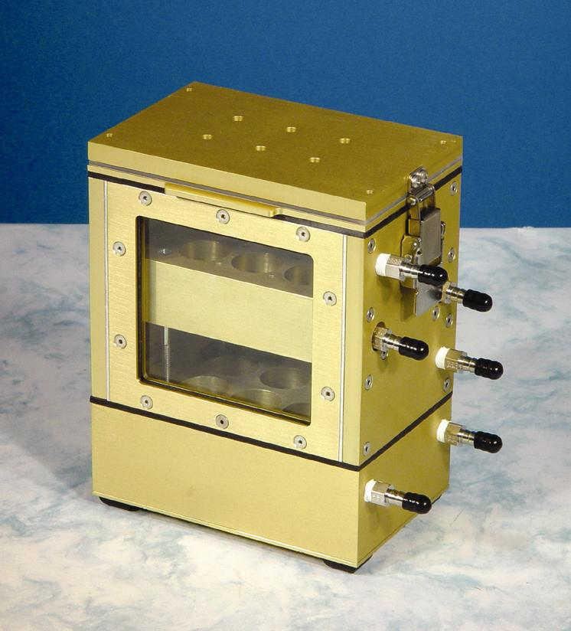
Reaction Setup
1. Remove the reactor cover by opening the 4 latches on the ends of the reactors cover.  2. Remove the septum retaining plate, the septum sheet, and septum cover.  3. At this point the reaction tubes can be freely inserted and removed. Set up any reactions that need to be run.  4. Place the septum retaining plate (the thin plate) over the 4 alignment posts on the reactors top so that the plate is square with the reactor base (note that this plate is polarized and fits properly in one direction while being offset in the other direction). | 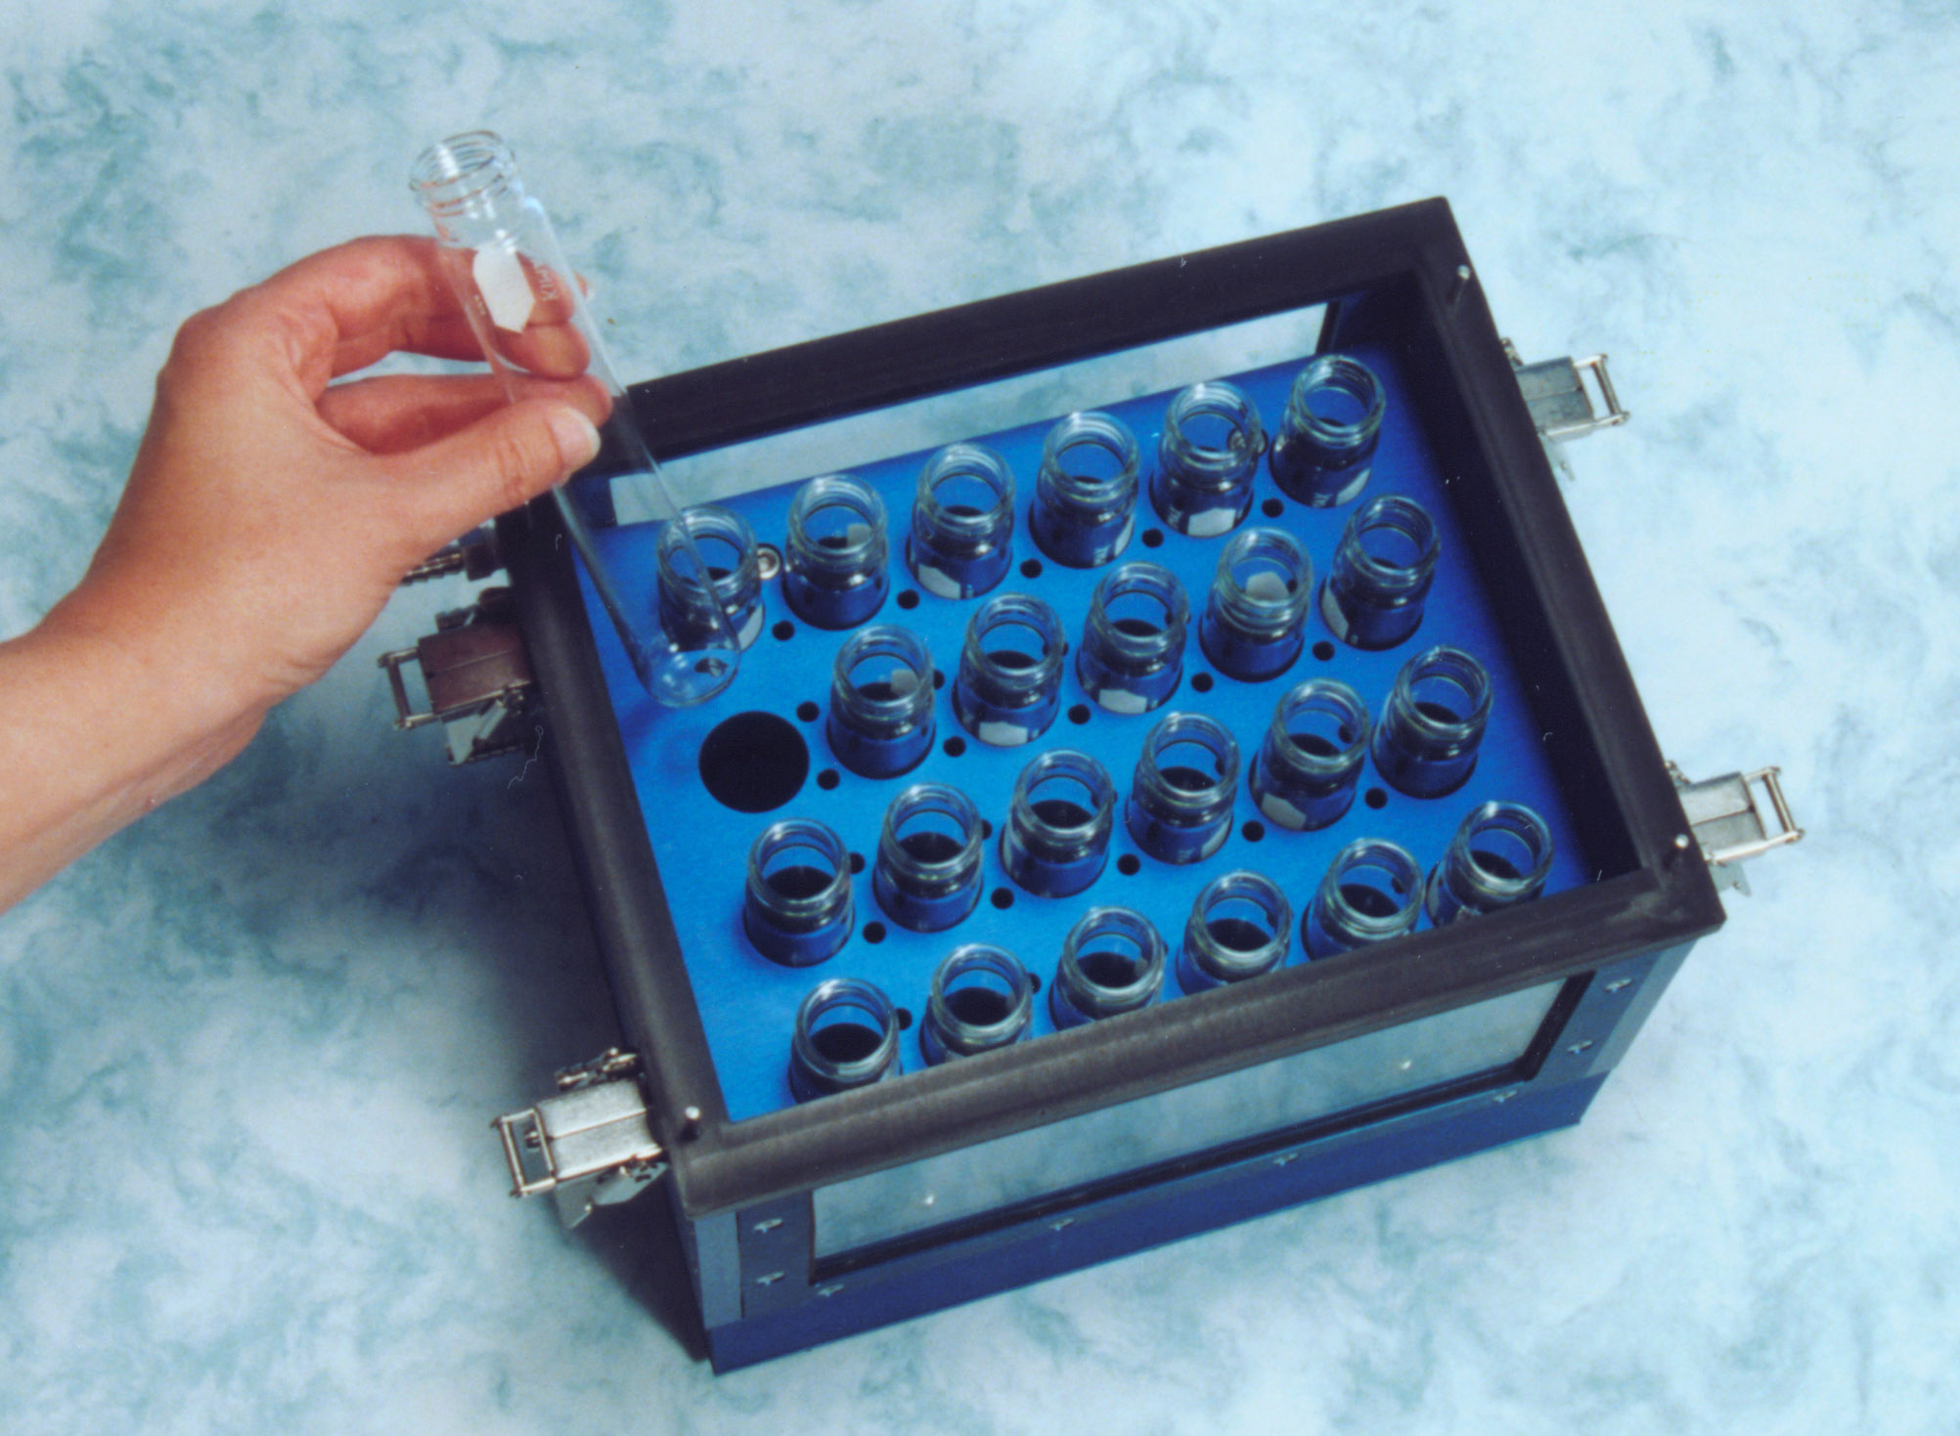
5. Place the Teflon septum sheet over the 4 alignment post making sure that the white Teflon face is down against and even with the septum retaining plate.
6. Place the septum cover over the 4 alignment posts so that it’s even with the reactor and the latch clips are pointed down. Fasten all 4 of the reactor’s latches.
7. Heating: To heat the reactor enter a setpoint temperature into the controller.
Cooling: To cool the reaction mixture, connect a recirculating chiller of other chilled fluid to the two bottom stainless steel ports labeled “Reaction Cooling In” and “Reaction Cooling Out” in the photograph above. The temperature controller can be connected to the reactor to monitor temperature, but the controllers setpoint temperature MUST be set lower than the reaction temperature or the controller will attempt to heat the reactor.
Reflux: The temperature controller should be set 1-2º C higher that the boiling point of the reaction solvent. A chilled fluid must be circulated through the stainless steel ports labeled “Reflux Cooling In” and “Reflux Cooling Out” in the photograph above. The temperature of the condensing fluid must be low enough to efficiently condense the reaction solvent.
8. An inert atmosphere can be maintained inside the reactor and inside all reaction tubes by means of a constant stream of inert gas entering and exiting through the stainless steel ports labeled “N2 In” and “N2 Out” in the photograph above. The top of the reaction tubes come close to the top of the reactor, but they do not touch, so that all reaction tubes are open to the inert atmosphere.
9. Reagents and solvents can be added by means of septumed ports directly above each reactor position.
Safety Notices: The KEM-Prep reactor is not designed to be exposed to elevated pressures or vacuums. Do not pressurize or evacuate the KEM-Prep reactor.
Mixing Reactions

The KEM-Prep reactor can either be magnetically stirred using a multi-position magnetic stirrer such as made by Brinkman or Variomag. An attractive alternative to magnetic stirring is to place the reactor on a bench top shaker and shake the entire reactor. J-KEM offers two bench top shakers for this purpose and a shaker mounting plate for the KEM-Prep reactor.

III. Resetting the Controller to Original Factory Settings

J-KEM manufactures the most technically advanced temperature controller available which should give you consistently flawless control. If you have difficulty with your controller, a good place to start to correct the problem is by loading the original factory settings. If you still have difficulty with your controller, our Engineering department will help you resolve the problem.
1. | Press and hold in both the ⬇ and ⬆ keys on the front of the temperature meter until the word “tunE” appears in the display, then release both keys.
2. | Press the ⬇ key until “LEVL” appears in the display. Next, hold in the ‘*’ key, then while holding in the ‘*’ key press the ⬆ key until “3” appears in the display. Let go of all the keys.
3 | Press the ⬆ key until “VEr” appears in the display. Simultaineouly hold in the ⬇ and ⬆ key for about 10 seconds, until the work “ver” disappears and is replaced by something else. Let go of all the keys.
4 | Press the ⬆ key until “LOCk” appears in the display. Next, hold in the ‘*’ key, then while holding in the ‘*’ key press the ⬇ and ⬆ keys until the word “None” appears in the display. Let go of all the keys.
5 | Press and hold in both the ⬇ and ⬆ keys on the front of the temperature meter until the program mode is exited and the temperature appears on the screen.
6 | Press and hold in both the ⬇ and ⬆ keys on the front of the temperature meter until the word “tunE” appears in the display, then release both keys. This reentered programming mode.
7 | Press the ⬇ key until “LEVL” appears in the display. Next, hold in the ‘*’ key, then while holding in the ‘*’ key press the ⬆ key until “3” appears in the display. Let go of all the keys.
8 | Press the ⬆ key until “rSEt” appears in the display. Next, hold in the ‘*’ key, then while holding in the ‘*’ key press the ⬆ key until the word “All” appears in the display. Let go of all the keys.
9. | Press and hold in both the ⬇ and ⬆ keys until the word “inPt” appears in the display, then release both keys.  The value that needs to be entered depends of the type of thermocouple receptacle your controller was shipped with.  Determine the thermocouple type below.  Color of thermocouple receptacle (Fig 1; # 5) Value to enter:  Blue (type T) “tc ”  Yellow (type K) “tc ”  Black (type J) “tc ”  White (RTD) “rtd”  First hold in the ‘*’ key, then while holding in the ‘*’ key press the ⬆ key until the value from the table above appears in the display. Let go of all the keys. NOTE: Many of the patterns for this parameter look similar, be careful to select the exact pattern shown above.
10. | Press the ⬆ key once and “unit” will appear in the display. Next, hold in the ‘*’ key, then while holding in the ‘*’ key press the ⬆ key until the value “o C” appears in the display,. Let go of all the keys.
11. | Press the ⬆ key once and the word “SP1.d” appears in the display. Next, hold in the ‘*’ key, then while holding in the ‘*’ key press the ⬆ key until the value “SSd” appears in the display. Let go of all the keys.
12. | Press the ⬆ key until “LEVL” appear in the display. Next, hold in the ‘*’ key, then while holding in the ‘*’ key press the ⬇ key and “4” will appear in the display,. Let go of all the keys.
13. | Press the ⬆ key until “no.AL” appears in the display, then let go of all keys. Next, hold in the ‘*’ key, then while holding in the ‘*’ key press the ⬆ key until the value “ON” appears in the display,. Let go of all the keys.
14. | Press in both the ⬇ and ⬆ keys until the temperature appears in the display (“PArk” also appears), then release both keys.
15. | Press and hold in both the ⬇ and ⬆ keys on the meter until the word “tunE” appears in the display, then release both keys.
16. | Press the ⬆ key once and the word “bAnd” will appear in the display. Next, hold in the ‘*’ key, then while holding in the ‘*’ key press the ⬆ or ⬇ key until the value “6” appears in the display. Let go of all the keys.
17. | Press the ⬆ key once and the word “int.t” will appear in the display. Next, hold in the ‘*’ key, then while holding in the ‘*’ key press the ⬆ or ⬇ key until the value “1.4” appears in the display. Let go of all the keys.
18. | Press the ⬆ key once and the word “dEr.t” will appear in the display.  Next, hold in the ‘*’ key, then while holding in the ‘*’ key press the ⬆ or ⬇ key until the value “7” appears in the display. Let go of all the keys.
19. | Press the ⬆ key once and the word “dAC” will appear in the display. Next, hold in the ‘*’ key, then while holding in the ‘*’ key press the ⬆ or ⬇ key until the value “1.0” appears in the display. Let go of all the keys.
20. | Press the ⬆ key once and the word “CyC.t” will appear in the display. Next, hold in the ‘*’ key, then while holding in the ‘*’ key press the ⬆ or ⬇ key until the value “6” appears in the display. Let go of all the keys.
21. | Press the ⬆ key until the word “SPrn” appears in the display. Next, hold in the ‘*’ key, then while holding in the ‘*’ key press the ⬇ or ⬆ key until the word “OFF” is displayed. Let go of all the keys.
22. | Press the ⬇ key until the word “LEVL” appears in the display.
23. | Hold in the ‘*’ key, then while holding in the ‘*’ key press the ⬆ key until “2” appears in the display. Let go of all the keys.
24. | Press the ⬆ key until “SP2.A” appears in the display. Next, hold in the ‘*’ key, then while holding in the ‘*’ key press the ⬆ key until the word “Dvhi” appears in the display. Let go of all the keys.
25. | Press the ⬆ key until “diSP” appears in the display. Next, hold in the ‘*’ key, then while holding in the ‘*’ key press the ⬇ or ⬆ key until the value “0.1o” appears in the display. Let go of all the keys.
26. | Press the ⬆ key until “Lo.SC” appears. Next, hold in the ‘*’ key, then while holding in the ‘*’ key press the ⬇ key until the number in the display stops changing (this will be 0, -50, or –199.9 depending on thermocouple type). Let go of all the keys.
27. | Press the ⬇ key until the word “LEVL” appears in the display.
28. | Hold in the ‘*’ key, then while holding in the ‘*’ key press the ⬆ key until “3” appears in the display. Let go of all the keys.
29. | Press the ⬆ key until “SPAn” appears in the display. Next, hold in the ‘*’ key, then while holding in the ‘*’ key press the ⬇ or ⬆ key  until the value ________________ appears in the display. Let go of all the keys.
30. | Press the ⬆ key until “ZEro” appears in the display. Next, hold in the ‘*’ key, then while holding in the ‘*’ key press the ⬇ or ⬆ key  until the value ________________ appears in the display. Let go of all the keys.
31. | Press the ⬇ key until the word “LEVL” appears in the display.
32. | Hold in the ‘*’ key, then while holding in the ‘*’ key press the ⬇ key until “1” appears in the display. Let go of all the keys.
33. | Press the ⬆ key until “SEt.2” appears in the display. Next, hold in the ‘*’ key, then while holding in the ‘*’ key press the ⬆ or ⬇ keys until the value 5.0 is entered. Let of go of all keys. If your controller does not have a USB port on the back, skip to step 31.
34. | Press the ⬆ key once and the word “bnd.2” will appear in the display. Next, hold in the ‘*’ key, then while holding in the ‘*’ key press the ⬆ or ⬇ key until the value “0.1” appears in the display. Let go of all the keys.
35. | Press the ⬇ key until the word “LEVL” appears in the display.
36. | First hold in the ‘*’ key, then while holding in the ‘*’ key press the ⬇ key until “C” appears in the display. Let go of all the keys.
37. | Press the ⬆ key and “Addr” will appear in the display. Next, hold in the ‘*’ key, then while holding in the ‘*’ key press the ⬇ or ⬆ key until the value “1” appears in the display. Let go of all the keys.
38. | Press the ⬆ key and “bAud” will appear in the display. Next, hold in the ‘*’ key, then while holding in the ‘*’ key press the ⬇ or ⬆ key until the value “9600” appears in the display. Let go of all the keys.
39. | Press the ⬆ key and “dAtA” will appear in the display. Next, hold in the ‘*’ key, then while holding in the ‘*’ key press the ⬇ or ⬆ key until the value “18n1” appears in the display. Let go of all the keys.
40. | Press and hold in both the ⬆ or ⬇ keys until the temperature appears in the display, then release both keys. The word “PArk” in the display will go away when a set point is entered.

